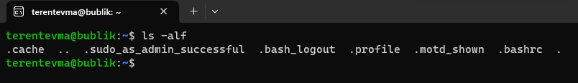

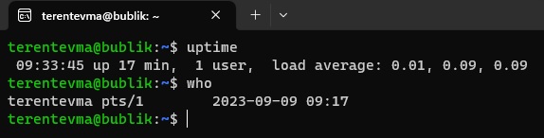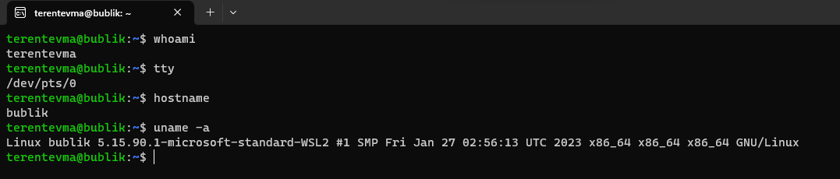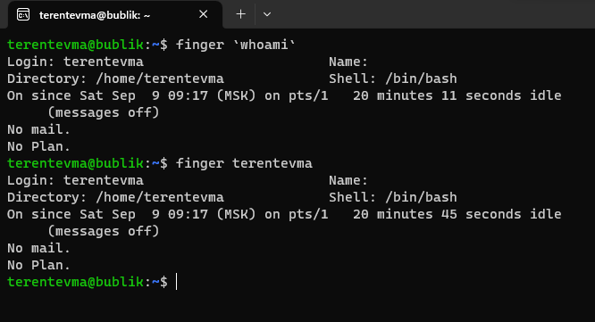

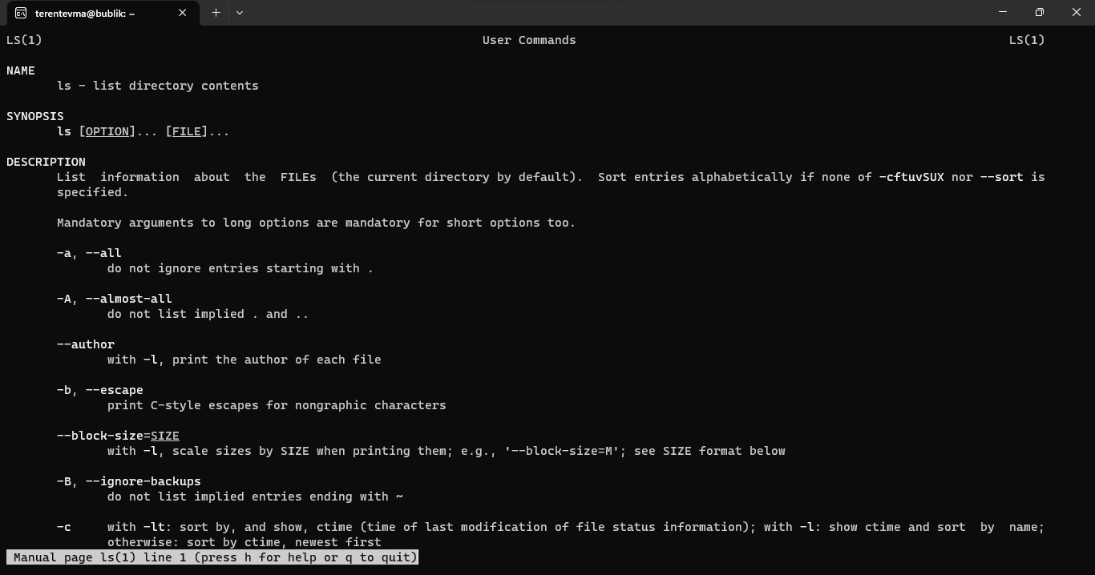

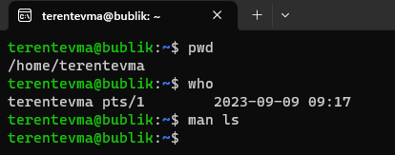

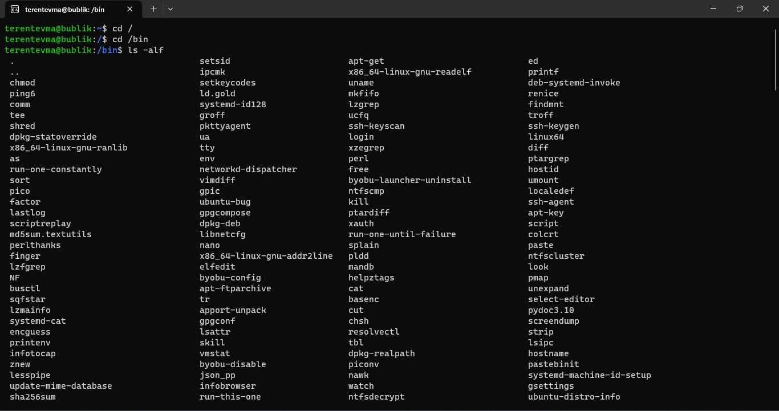

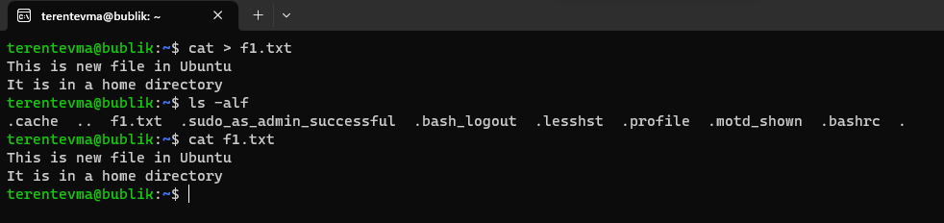

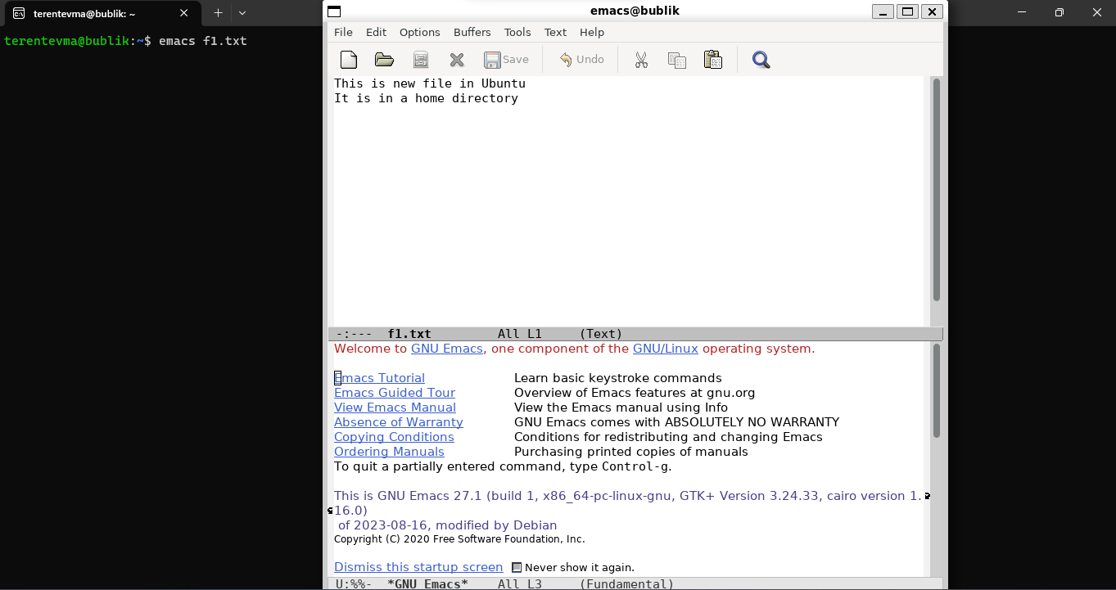

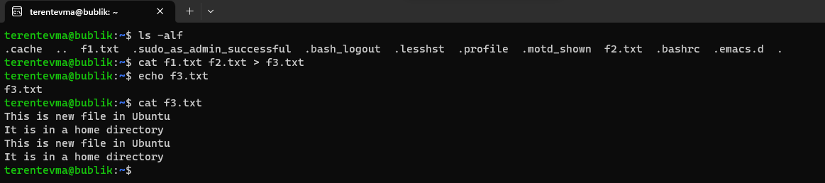

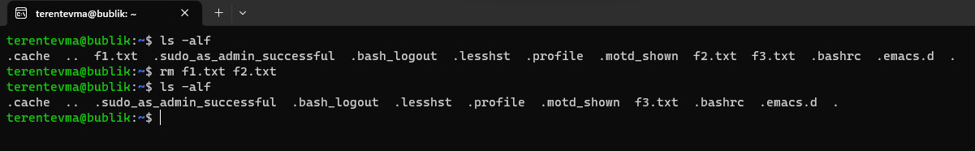

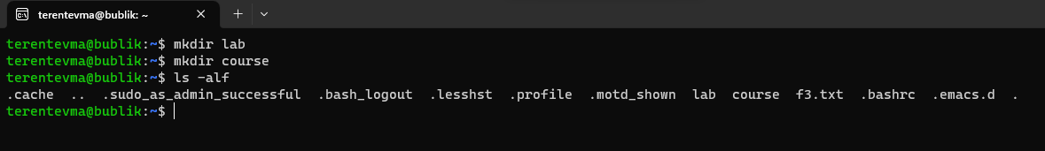

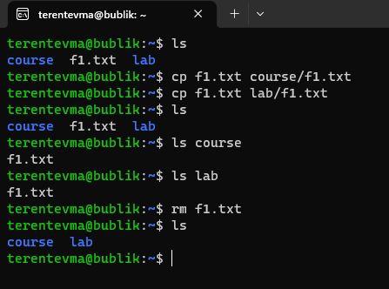

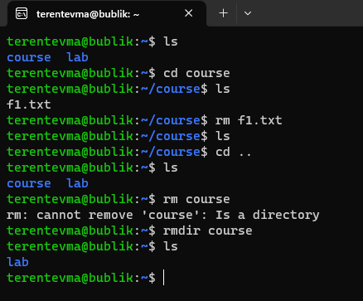

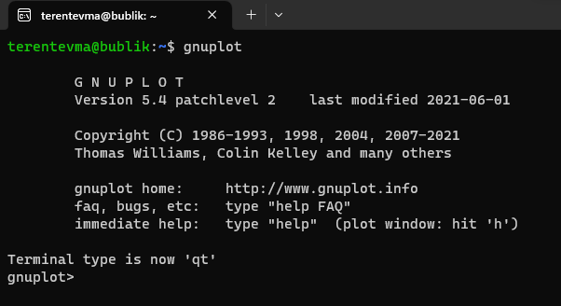

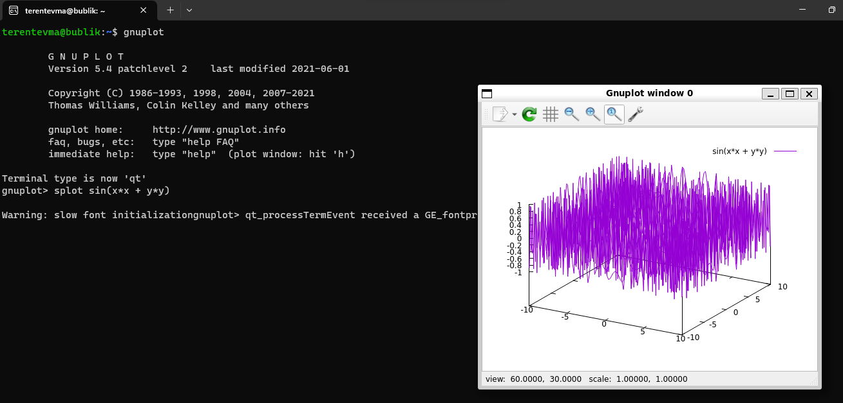

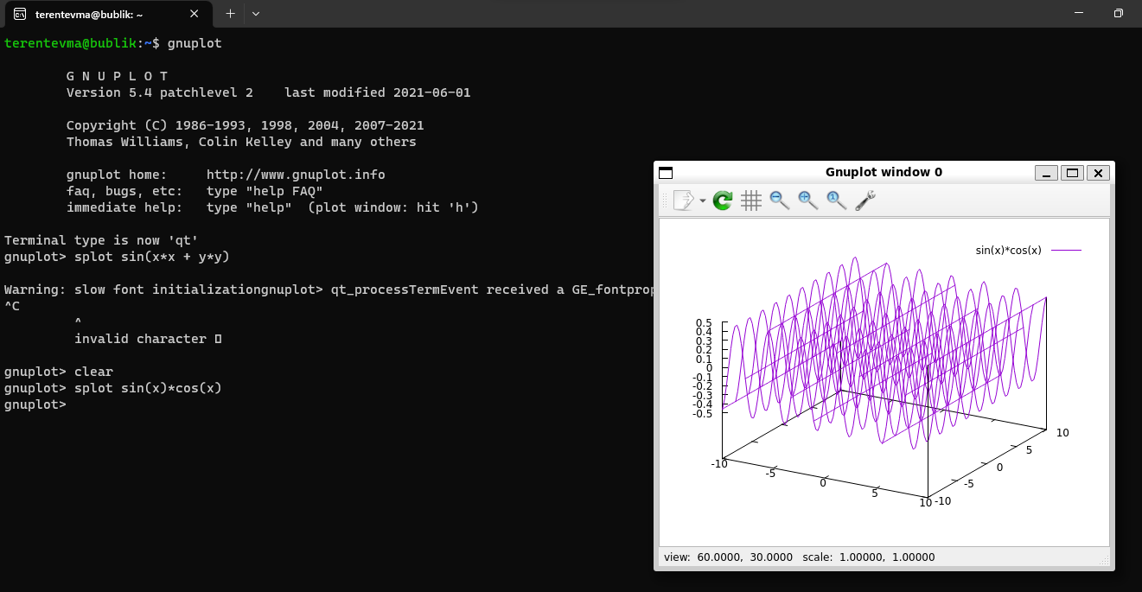

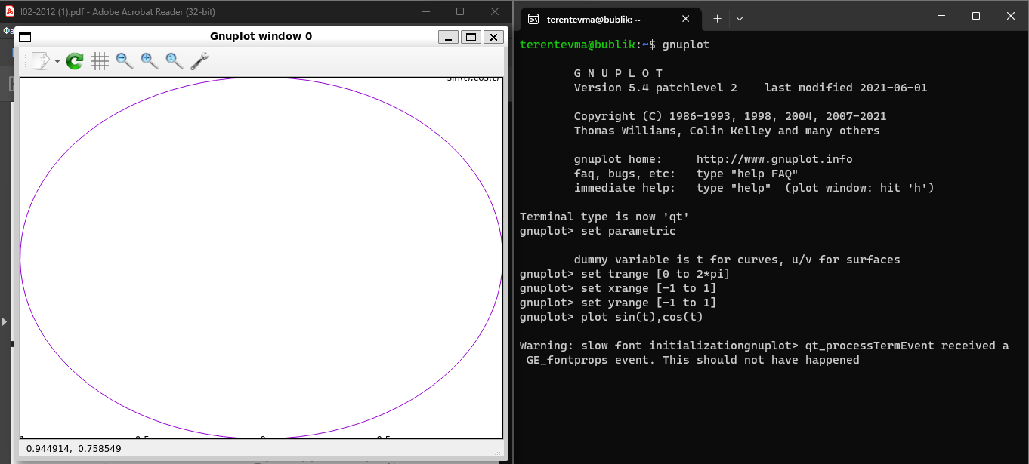

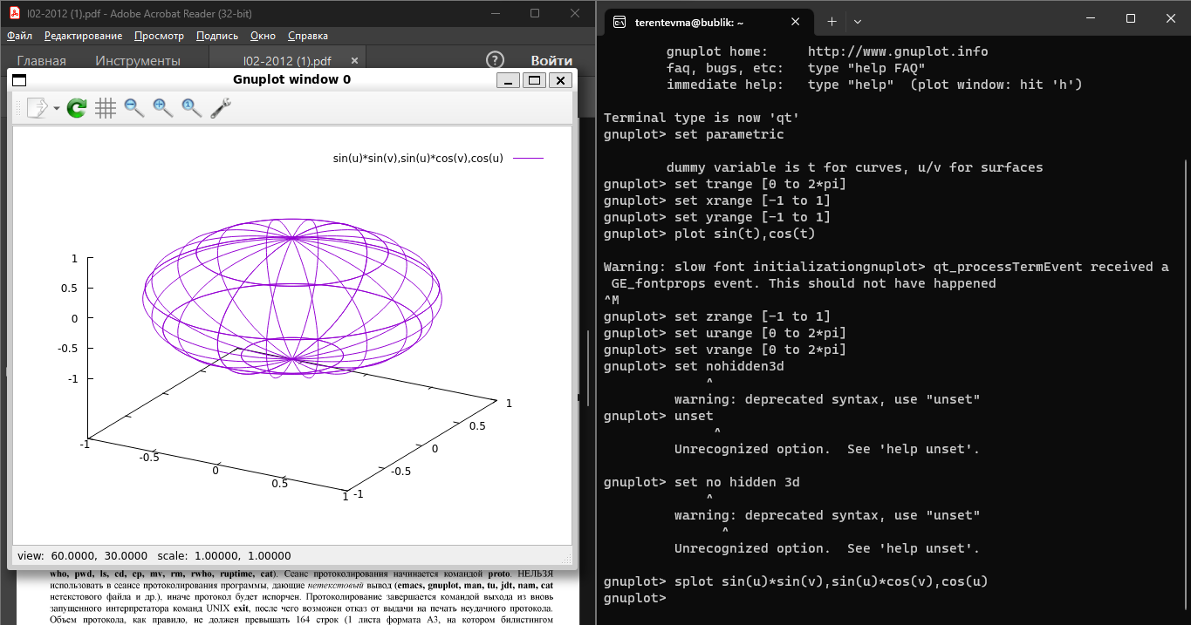

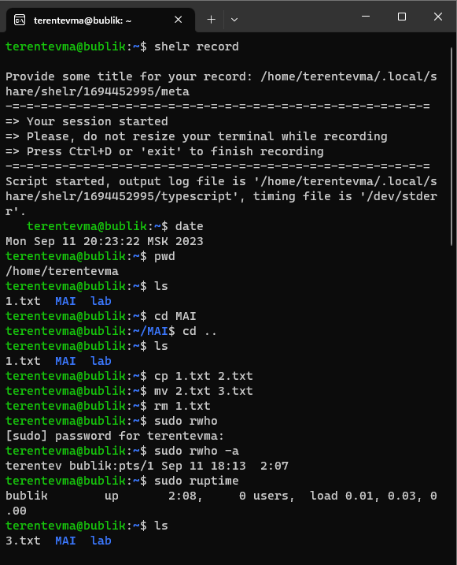

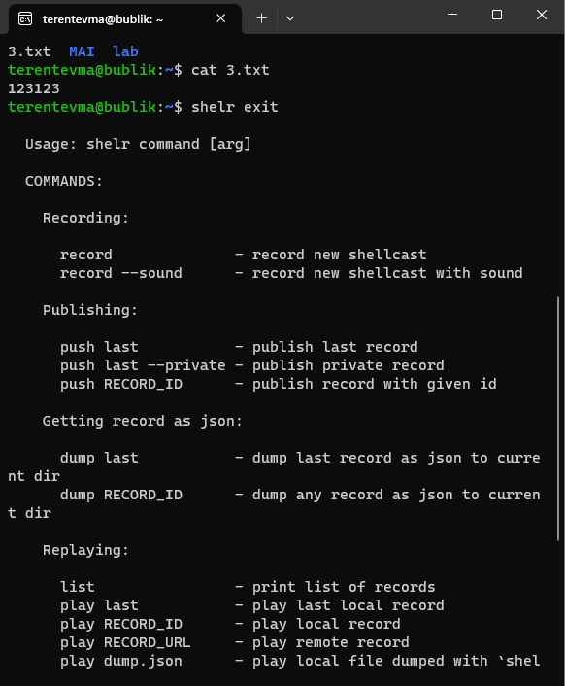

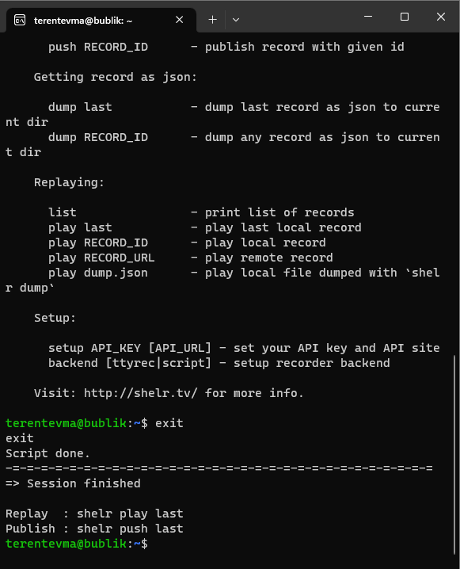

terentevma@bublik:~$ shelr record

Provide some title for your record: /home/terentevma/.local/share/shelr/1694452995/meta

-=-=-=-=-=-=-=-=-=-=-=-=-=-=-=-=-=-=-=-=-=-=-=-=-=-=-=-=-=-=

=> Your session started

=> Please, do not resize your terminal while recording

=> Press Ctrl+D or 'exit' to finish recording

-=-=-=-=-=-=-=-=-=-=-=-=-=-=-=-=-=-=-=-=-=-=-=-=-=-=-=-=-=-=

Script started, output log file is '/home/terentevma/.local/share/shelr/1694452995/typescript', timing file is '/dev/stderr'.

terentevma@bublik:~$ date

Mon Sep 11 20:23:22 MSK 2023

terentevma@bublik:~$ pwd

/home/terentevma

terentevma@bublik:~$ ls

1.txt MAI lab

terentevma@bublik:~$ cd MAI

terentevma@bublik:~/MAI$ cd ..

terentevma@bublik:~$ ls

1.txt MAI lab

terentevma@bublik:~$ cp 1.txt 2.txt

terentevma@bublik:~$ mv 2.txt 3.txt

terentevma@bublik:~$ rm 1.txt

terentevma@bublik:~$ sudo rwho

[sudo] password for terentevma:

terentevma@bublik:~$ sudo rwho -a

terentev bublik:pts/1 Sep 11 18:13 2:07

terentevma@bublik:~$ sudo ruptime

bublik up 2:08, 0 users, load 0.01, 0.03, 0.00

terentevma@bublik:~$ ls

3.txt MAI lab

terentevma@bublik:~$ cat 3.txt

123123

terentevma@bublik:~$ shelr exit

Usage: shelr command [arg]

COMMANDS:

Recording:

record - record new shellcast

record --sound - record new shellcast with sound

Publishing:

push last - publish last record

push last --private - publish private record

push RECORD_ID - publish record with given id

Getting record as json:

dump last - dump last record as json to current dir

dump RECORD_ID - dump any record as json to current dir

Replaying:

list - print list of records

play last - play last local record

play RECORD_ID - play local record

play RECORD_URL - play remote record

play dump.json - play local file dumped with `shelr dump`

Setup:

setup API_KEY [API_URL] - set your API key and API site

backend [ttyrec|script] - setup recorder backend

Visit: http://shelr.tv/ for more info.

terentevma@bublik:~$ exit

exit

Script done.

-=-=-=-=-=-=-=-=-=-=-=-=-=-=-=-=-=-=-=-=-=-=-=-=-=-=-=-=-=-=

=> Session finished

Replay : shelr play last

Publish : shelr push last

terentevma@bublik:~$